תצוגת גביש נוזלי

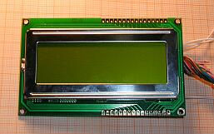

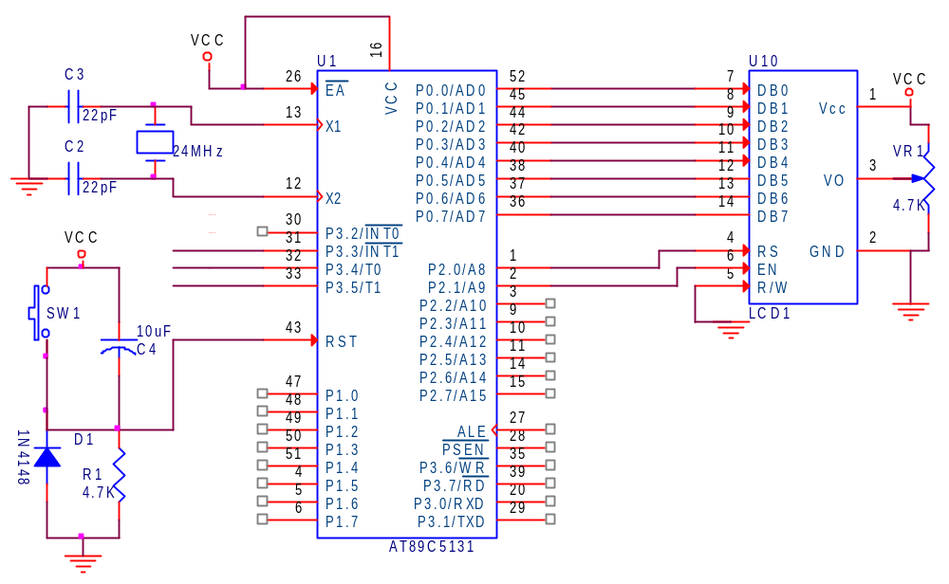
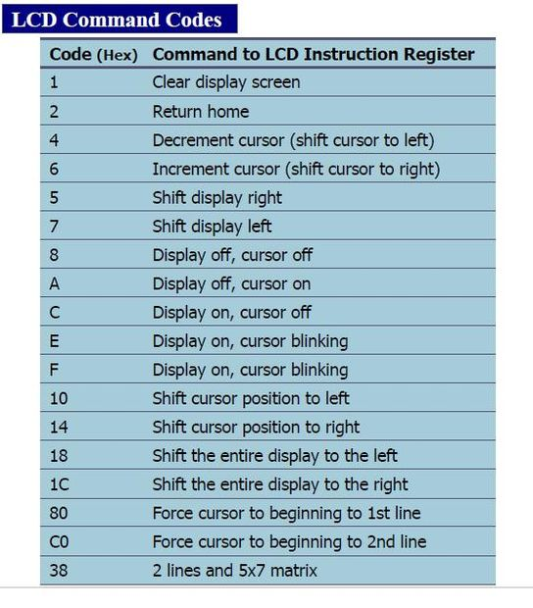
Writing to Display Procedure:
- Set the RS (Register Select) pin to 0 or 1 to indicate whether the command is directed to the command register or the data register.
- Set the RW (Read/Write) pin to 0 to inform the display that a write operation is being performed.
- Set the EN (Enable) pin to "1."
- Place the data/instruction on the data lines DB0-DB7.
- Lower the EN pin to "0" to latch the instruction or data into the display.

After lowering the EN pin to 0, wait until the LCD completes the current operation. This can be achieved using a delay function.
This code appears to be a program written in C for controlling an LCD display using an 8051 microcontroller:
#include<reg51.h>

void Init_LCD(void);
void Clear(void);
void Delay(unsigned int);
void Message(unsigned char[]);
void Out(unsigned char);
void Next_Line(void);
void LCD_Cmnd(unsigned char);
void LCD_Data(unsigned char);

sbit rs=P2^0;
sbit en=P2^1;

void main(void)
{
en=0;
Init_LCD();
Message("Hello");
Next_Line();
Message("Everybody!");
while(1);
}

void Init_LCD(void)
{
LCD_Cmnd(0x38); // data length
LCD_Cmnd(0x0e); // display on & cursor on
LCD_Cmnd(0x06); // direction & no shift display
Clear();
}

void Clear(void)
{
LCD_Cmnd(0x01); // display clear
}

void Delay(unsigned int Time)
{
unsigned int x,y;

for(x=0;x<Time;x++)
for(y=0;y<=152;y++); // 1ms on 24MHz quartz
}

void Message(unsigned char Array[])
{
int i=0;
while(Array[i]!='\0')
{
LCD_Data(Array[i++]);
}
}

void Out(unsigned char Symb)
{
LCD_Data(Symb);
}

void Next_Line(void)
{
LCD_Cmnd(0xc0); // cursor to line 2
}

void LCD_Cmnd(unsigned char cmd)
{
P0=cmd;
rs=0;
en=1;
Delay(2);
en=0;
Delay(10);
}

void LCD_Data(unsigned char dat)
{
P0=dat;
rs=1;
en=1;
Delay(2);
en=0;
Delay(10);
}

